Stars within 10 Light Years
Every known star within 10 light years: 11 stars in 7 systems, plus the Sun. Only Sirius and Alpha Centauri A and B are bright enough to see with the naked eye; the rest are red dwarfs and one white dwarf. Bright stars from Hipparcos (2007), faint ones from Gaia DR3. Two brown dwarf systems also lie within 10 light years, Luhman 16 A and B (6.5 ly) and WISE 0855−0714 (7.4 ly); they are not stars and are too faint for both catalogues, so they are not listed. Planets: NASA Exoplanet Archive, 11 October 2026.
Catalog Name | RA (h m) | Dec (d m) | Galactic l | Galactic b | Classification | Visual Mag | Abs Mag | Prllx (mas) | Dist (ly) | Gliese Number | Proper Name | Proper motion (″/yr) | Tangential speed (km/s) | Radial velocity (km/s) | Notes
Sun | --- | --- | -- | -- | G2V | -26.74 | 4.83 | -- | 0.00 | -- | Sol | -- | -- | -- | Has 8 planets
Alpha Centauri B | 14 39.4 | -60 52 | 315.7 | -0.7 | K1V | 1.35 | 5.86 | 796.92 | 4.10 | Gl 559 B | Toliman | 3.703 | 22.0 | -20.6
Proxima Centauri | 14 29.6 | -62 41 | 313.9 | -1.9 | M5.5V | 11.13 | 15.56 | 768.07 | 4.25 | Gl 551 | Proxima | 3.859 | 23.8 | -21.9 | Nearest star to the Sun, 0.2 ly from Alpha Centauri A and B. Has 2 planets
Alpha Centauri A | 14 39.4 | -60 52 | 315.7 | -0.7 | G2V | -0.01 | 4.38 | 754.81 | 4.30 | Gl 559 A | Rigil Kentaurus | 3.710 | 23.3 | -21.4
Barnard’s Star | 17 57.8 | +04 44 | 31.0 | +14.1 | M4V | 9.54 | 13.23 | 546.98 | 5.96 | Gl 699 |  | 10.393 | 90.1 | -110.5 | Fastest proper motion of any star, 10.4″ a year: the width of the full Moon in 180 years. Has 4 planets
Wolf 359 | 10 56.4 | +07 00 | 244.1 | +56.1 | M6V | 13.51 | 16.60 | 415.18 | 7.86 | Gl 406 |  | 4.715 | 53.8 | +19.5 | Flare star
Lalande 21185 | 11 03.3 | +35 57 | 185.2 | +65.4 | M2V | 7.52 | 10.49 | 392.75 | 8.30 | Gl 411 |  | 4.812 | 58.1 | -85.1 | Brightest red dwarf in the northern sky (still too faint for the naked eye). Has 2 planets
Alpha Canis Majoris A | 06 45.1 | -16 42 | 227.2 | -8.9 | A1V | -1.44 | 1.45 | 379.21 | 8.60 | Gl 244 A | Sirius | 1.339 | 16.7 | -5.5
Alpha Canis Majoris B | 06 45.1 | -16 43 | 227.2 | -8.9 | DA2 | 8.44 | 11.33 | 379.21 | 8.60 | Gl 244 B | Sirius B | 1.339 | 16.7 | -5.5 | White dwarf companion of Sirius
Luyten 726-8 B | 01 39.1 | -17 57 | 175.5 | -75.7 | M6V | 12.99 | 15.85 | 373.84 | 8.72 | Gl 65 B | UV Ceti | 3.232 | 41.0 | +32.0 | UV Ceti, the prototype flare star
Luyten 726-8 A | 01 39.1 | -17 57 | 175.5 | -75.7 | M5.5V | 12.54 | 15.37 | 367.71 | 8.87 | Gl 65 A | BL Ceti | 3.429 | 44.2 | +29.0
Ross 154 | 18 49.8 | -23 50 | 11.3 | -10.3 | M3.5V | 10.43 | 13.06 | 336.03 | 9.71 | Gl 729 |  | 0.668 | 9.4 | -11.1
Column 1: Bayer/Flamsteed designation, or the star’s number in the Harvard Revised Bright Star Catalogue (HR). Columns 2–3: right ascension (hours, minutes) and declination (degrees, minutes), epoch 2000. Columns 4–5: galactic longitude and latitude. Column 6: spectral class of the stars in the system. Column 7: apparent visual magnitude. Column 8: absolute magnitude (the magnitude at 32.6 light years). Column 9: parallax in milliarcseconds. Column 10: distance in light years (= 3261.56 / parallax). Column 11: number in the Gliese Catalogue of Nearby Stars. Column 12: proper name. Proper motion: the star’s motion across the sky in arcseconds per year; tangential speed: the same motion in km/s at the star’s distance; radial velocity: speed toward (−) or away from (+) the Sun.
Closest approach to the Sun (straight-line motion): Alpha Centauri B 27,800 years from now, at 2.99 ly; Proxima Centauri 26,600 years from now, at 3.12 ly; Alpha Centauri A 27,700 years from now, at 3.18 ly; Barnard’s Star 9,700 years from now, at 3.77 ly; Wolf 359 14,000 years ago, at 7.39 ly; Lalande 21185 20,000 years from now, at 4.68 ly; Alpha Canis Majoris A 45,700 years from now, at 8.17 ly; Alpha Canis Majoris B 45,700 years from now, at 8.17 ly; Luyten 726-8 B 31,000 years ago, at 6.88 ly; Luyten 726-8 A 27,600 years ago, at 7.42 ly; Ross 154: still coming closer after 60,000 years (7.71 ly then).

Maps
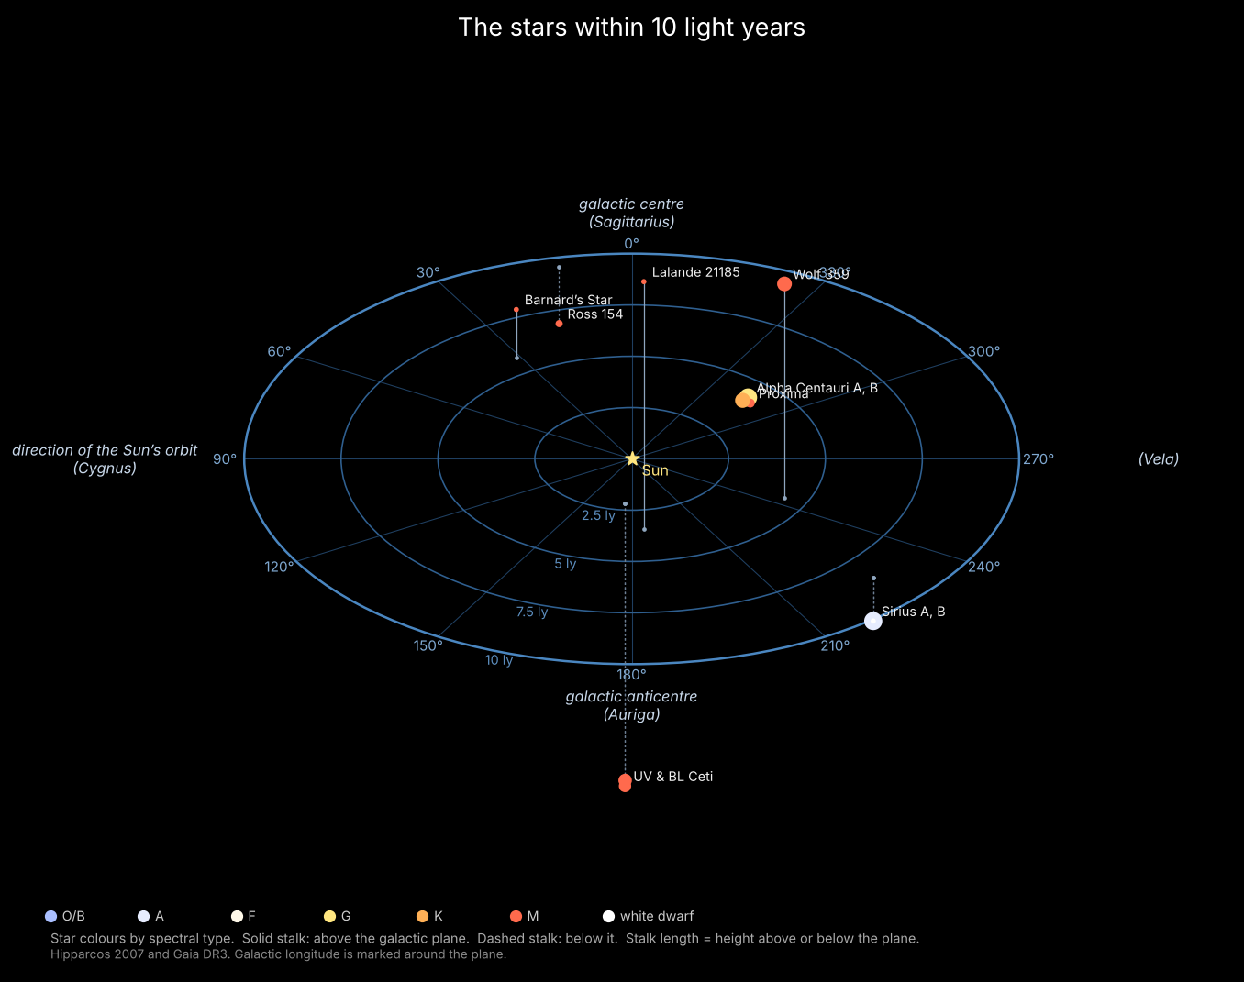
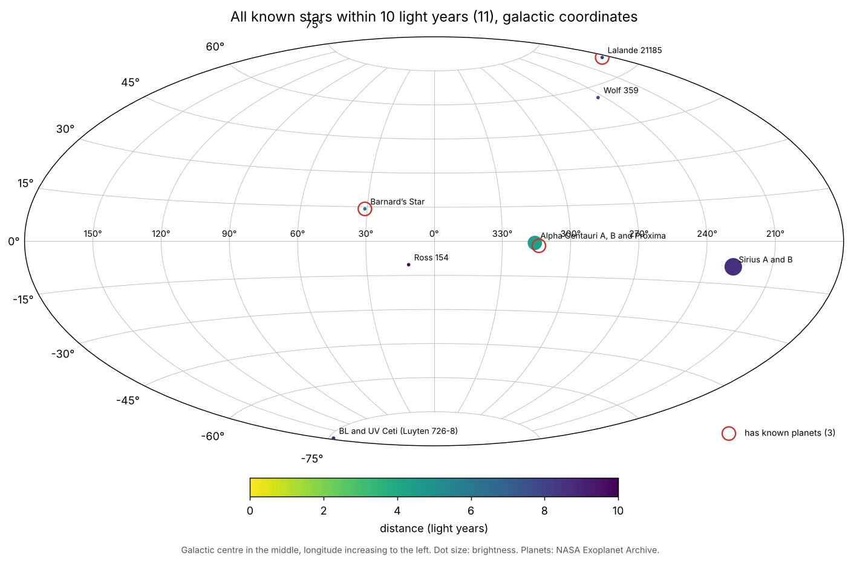
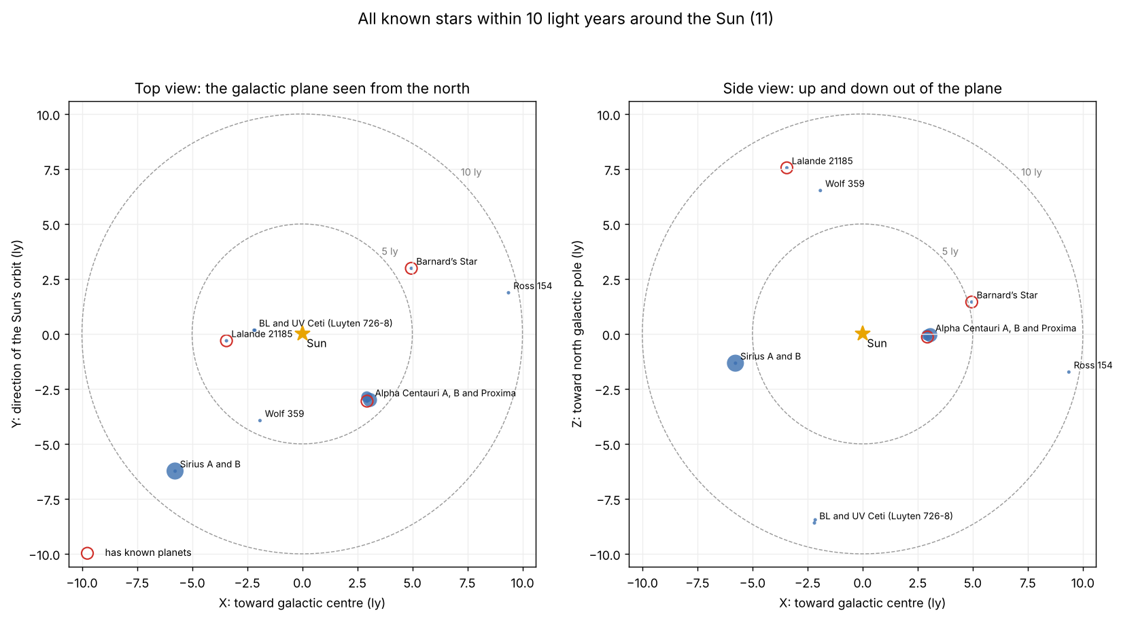
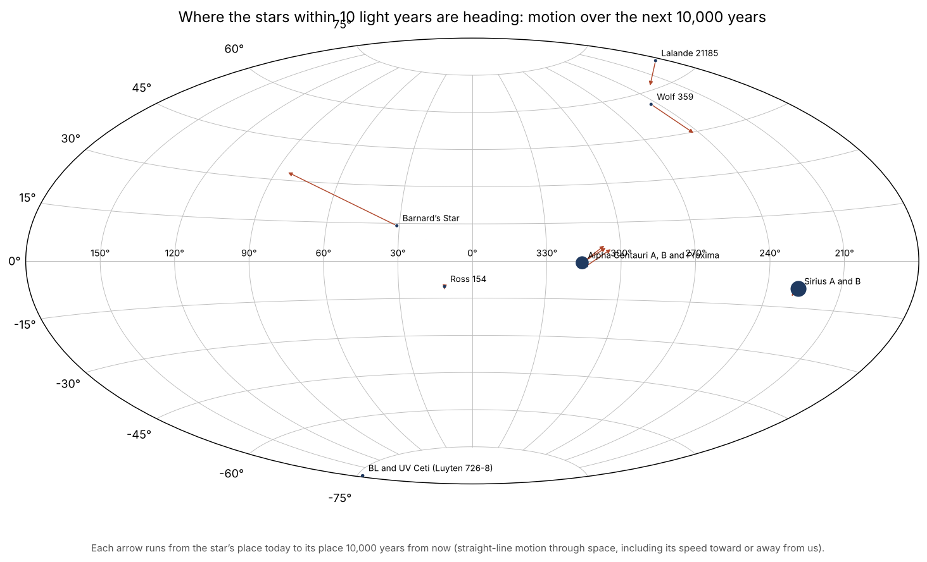
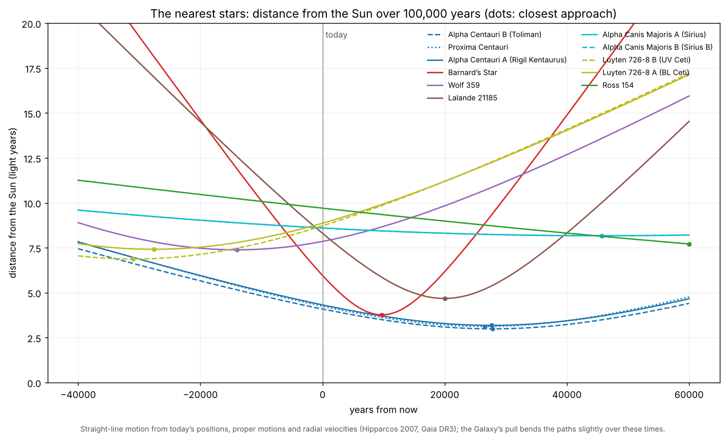

Sources
- van Leeuwen F. (2007), Hipparcos, the New Reduction of the Raw Data (parallaxes, proper motions), VizieR I/311.
- ESA (1997), The Hipparcos and Tycho Catalogues (magnitudes, spectral types), VizieR I/239.
- Kostjuk N.D. (2002), HD-DM-GC-HR-HIP-Bayer-Flamsteed Cross Index, VizieR IV/27A.
- Gaia Collaboration (2023), Gaia Data Release 3 (stars too faint for Hipparcos), ESA Gaia Archive.
- Gontcharov G.A. (2006), Pulkovo Compilation of Radial Velocities for 35,495 Hipparcos stars, VizieR III/252.
- NASA Exoplanet Archive, Planetary Systems Composite Parameters, exoplanetarchive.ipac.caltech.edu, accessed 11 October 2026.
- Gliese W., Jahreiß H. (1991), Third Catalogue of Nearby Stars; Hoffleit D., Warren W. (1991), Bright Star Catalogue, 5th ed.

